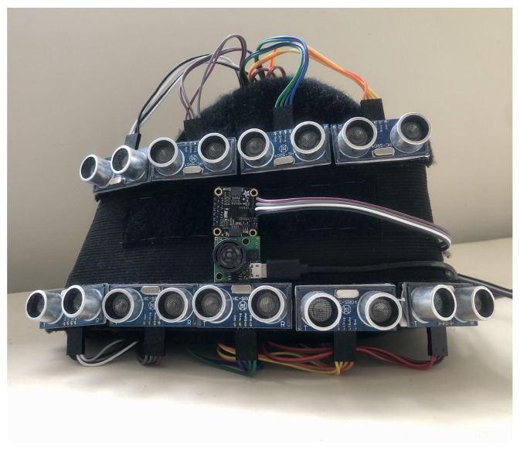Head-Mounted Obstacle Avoidance Wearable

Wearable haptic and obstacle avoidance device

Wearable assistive device integrating a Fuzzy Decision Support System

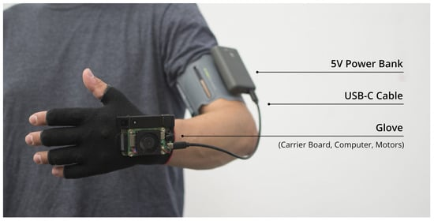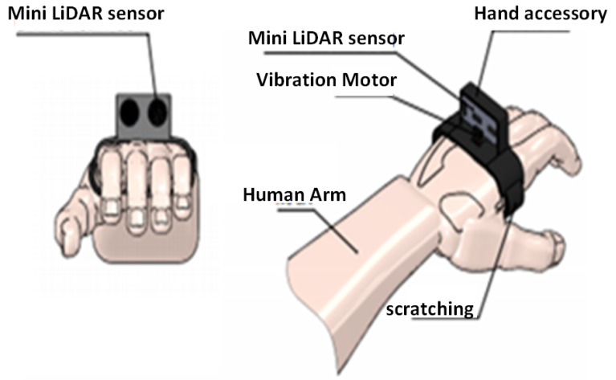Unfolding Space Glove

Smart Cane

Eye Substitution Device

Fusion of Artificial Visions and GPS

Radio Frequency Identification Walking Stick (RFIWS)

Silicone Eyes

Unav: A computer vision-based navigation aid